Form transfer PHP:

1 - adapt your first last practical work on form to submit the form and display the following page :

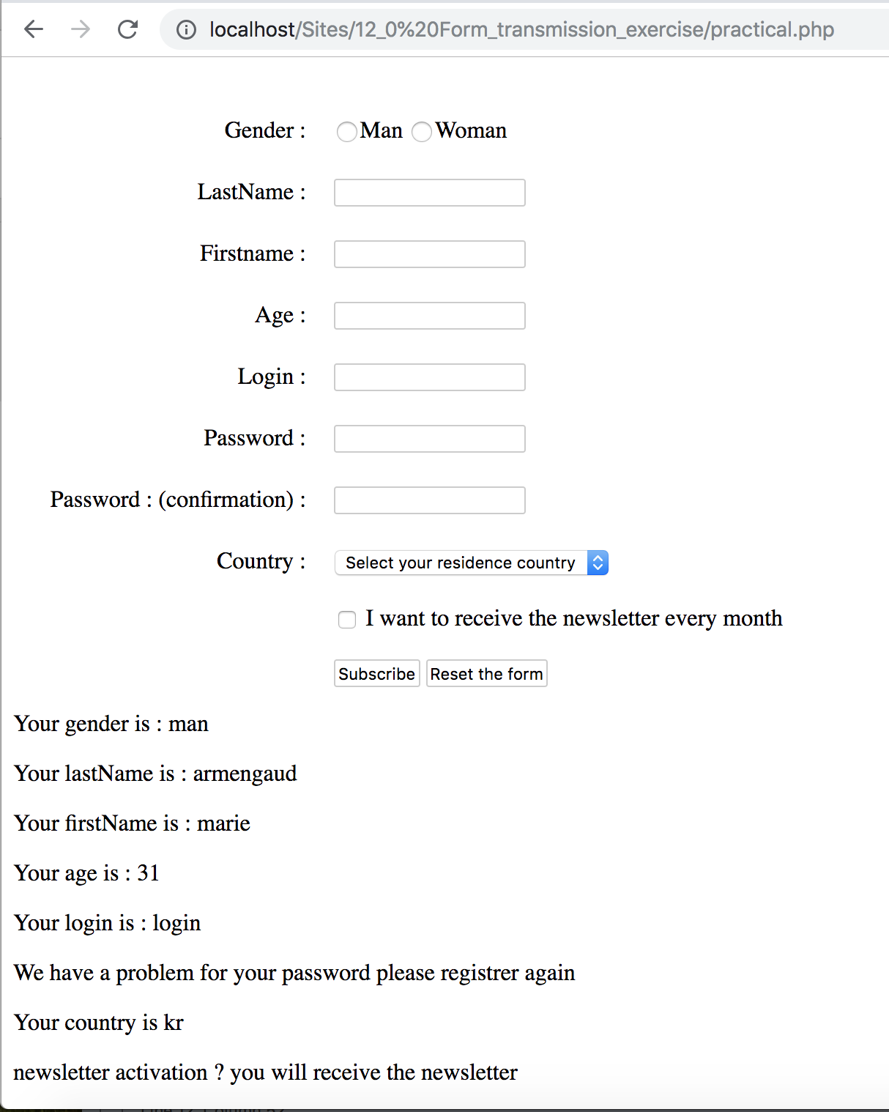

you will have to :

* do the submit action
* display after your form all the informations
* test every variables to display informations (be careful with the password :) )